# **Simulation Results**

In the simulation report, we simulated the circuit while N2/N/1=3/4. After changing that ratio to 4/4, we have updated the simulation results. Also, we have included all the nonidealities such as diode forward voltage, MOSFET RDS,ON, capacitor and inductor ESR values.

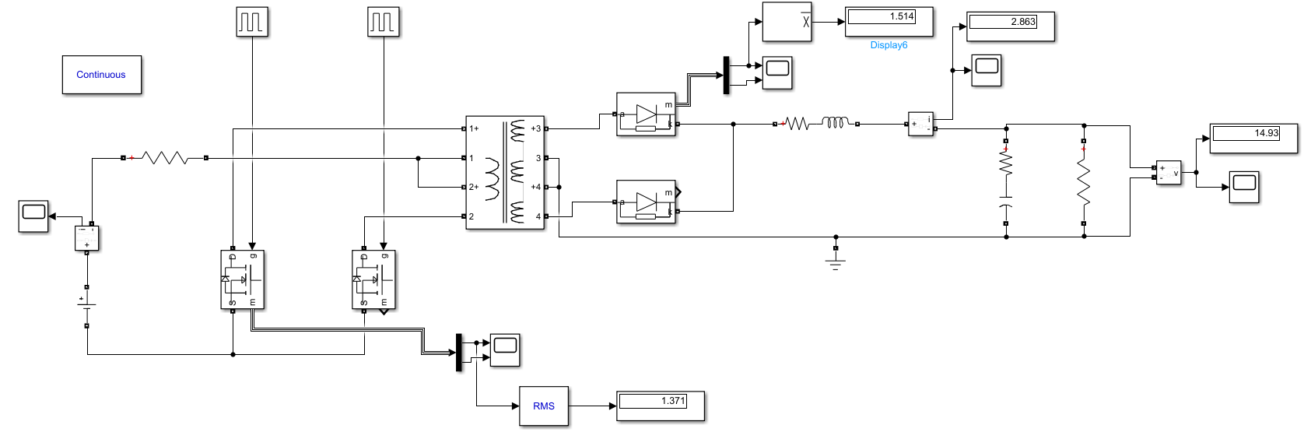

Figure-1: Simulation model of our circuit

When the input is 24V, with 0.44 duty cycle, simulation results including input current, output current & voltage, primary & secondary coil voltages, diode current & voltage, switch current & voltage are obtained as follows:



Figure-2: Output Voltage with 24V input



Figure-3: Output Current with 24V input



Figure-4: Switch current and voltage with 24V input



Figure-5: Diode current and voltage with 24V input

All those simulations are also done for 48V input, with a duty cycle of 0.16. Since we increased the inductance of the output inductor, we get less current ripple. On the other hand, due to the ESR of the output capacitors, we get a higher output voltage ripple around 200mV. Also, the diode maximum voltage is now doubled to 96V.



Figure-6: Output Voltage with 48V input



Figure-7: Output current with 48V input



Figure-8: Switch current and voltage with 48V input



Figure-9: Diode current and voltage with 48V input